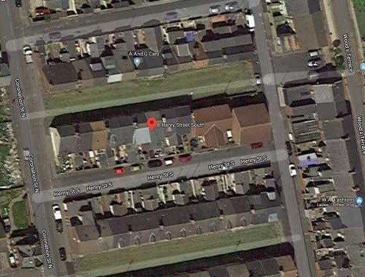
GUIDE PRICE £30,000
12
6 Henry Street North
Seaham, County Durham SR7 9AW
* PLUS 2% BUYERS PREMIUM PLUS VAT SUBJECT TO A MINIMUM OF £3500 +VAT
2 Bed Buy to let investment property
DESCRIPTION:
2 Bed terraced property achieving £300pcm
ACCOMMODATION
This 2 bed terraced property has gas central heating and is fully double glazed, the property consists of Lounge, dining room, fitted kitchen and downstairs family bathroom, to the first floor there is 2 good sized bedrooms
LOCATION:
Situated on Henry Street North, the property is close to all local amenities including, shops, schools and nurseries, with the Dalton Park outlet Centre being within a short distance. The property benefits from excellent public transport links and access to the A19 being only a few minutes away by car.
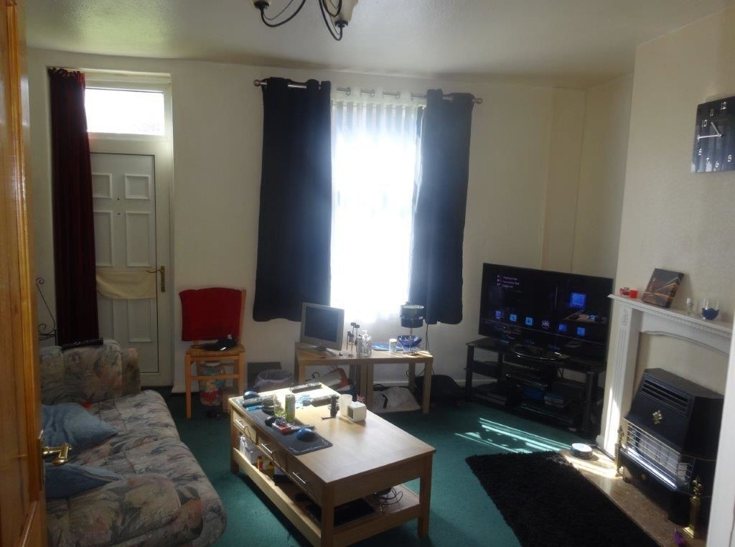
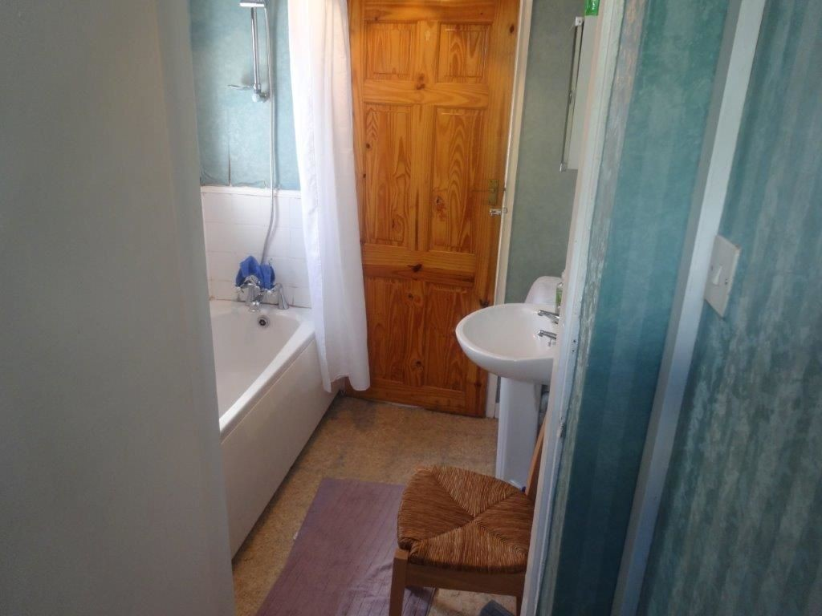
INCOME:
Currently achieving £300pcm on a 6 month AST.
TENURE:
Freehold
UNCONDITIONAL - Contracts are exchanged on the fall of the hammer and a 10% deposit will be taken from the highest bidder. This deposit will contribute towards the purchase price. In addition a 2% of the sale price buyers premium is payable upon the fall of the hammer ( subject to a minimum of £3500
+vat)

