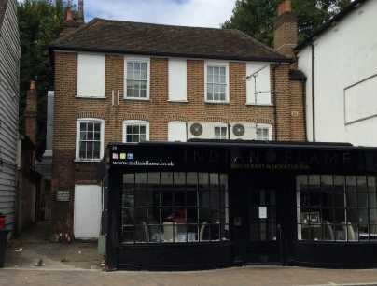
GUIDE PRICE £150,000
26
28A South Street Epsom, Surrey KT18 7PF
* PLUS 2% BUYERS PREMIUM PLUS VAT
Fantastic Buy to let or first time buyers apartment
- Spacious Top Floor Apartment
DESCRIPTION:
Beautfully presented spacious 1 bed apartment
ACCOMMODATION
The property is within a Grade 2 Listed building in the town centre. The property comprises of Entrance Hall, leading on to a spacious lounge area, a large fully fitted kitchen, A generous size bedroom and family size bathroom with shower and bath. To the rear of the property there is a shared garden with seating area.
LOCATION:
Property is Situated in the heart of the town centre, in a convenient position for Epsom town centre shops and walking distance of Epsom's Mainline Station.
GROUND RENT:
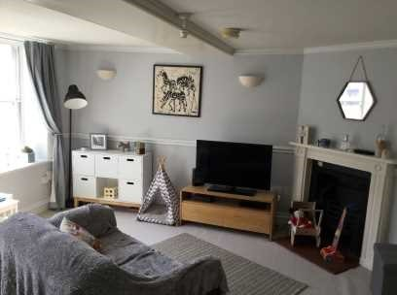
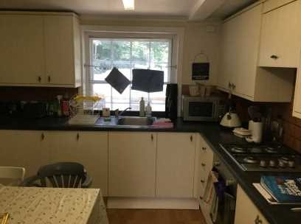
£10 per month
TENURE:
Leasehold 850 Years Remaining
UNCONDITIONAL - Contracts are exchanged on the fall of the hammer and a 10% deposit will be taken from the highest bidder. This deposit will contribute towards the purchase price. In addition a buyers premium of 2% of the sale price (subject to a minimum of £4000) +Vat is payable upon the fall of the hammer

